Lab-7

Book database

**Code:**

create database book_db;

use book_db;

CREATE TABLE Publisher

(name VARCHAR(20) PRIMARY KEY,

phone real,

address VARCHAR(20));

CREATE TABLE Book

(book_id int PRIMARY KEY,

title VARCHAR(20),

pub_year VARCHAR(20),

publisher_name varchar(20) REFERENCES Publisher (name) ON DELETE CASCADE);

CREATE TABLE Book_Authors

(author_name VARCHAR(20),

book_id int REFERENCES Book (book_id) ON DELETE CASCADE,

PRIMARY KEY (book_id, author_name));

CREATE TABLE Library_Branch

(branch_id int PRIMARY KEY,

branch_name VARCHAR(50),

address VARCHAR(50));

CREATE TABLE Book_Copies

(no_of_copies int,

book_id int REFERENCES Book(book_id) ON DELETE CASCADE,

branch_id int REFERENCES Library_Branch (branch_id) ON DELETE CASCADE,

PRIMARY KEY (book_id, branch_id));

CREATE TABLE Card

(card_no int PRIMARY KEY);

CREATE TABLE Book_Lending

(date_out DATE,

due_date DATE,

book_id int REFERENCES book (book_id) ON DELETE CASCADE,

branch_id int REFERENCES Library_Branch (branch_id) ON DELETE CASCADE,

card_no int REFERENCES Card (card_no) ON DELETE CASCADE,

PRIMARY KEY (book_id, branch_id, card_no));

INSERT INTO Publisher VALUES

("MCGRAW-HILL", 9989076587, "BANGALORE"),

("PEARSON",9889076565,"NEWDELHI"),

("RANDOM HOUSE",7455679345,"HYDRABAD"),

("HACHETTE LIVRE",8970862340,"CHENNAI"),

("GRUPO PLANETA",7756120238,"BANGALORE");

INSERT INTO Book VALUES

(1,"DBMS","JAN-2017","MCGRAW-HILL"),

(2,"ADBMS","JUN-2016","MCGRAW-HILL"),

(3,"CN","SEP-2016","PEARSON"),

(4,"CG","SEP-2015","GRUPO PLANETA"),

(5,"OS","MAY-2016","PEARSON");

INSERT INTO Book_Authors VALUES

("NAVATHE", 1),

("NAVATHE", 2),

("TANENBAUM", 3),

("EDWARD ANGEL", 4),

("GALVIN", 5);

INSERT INTO Library_Branch VALUES

(10,"RR NAGAR","BANGALORE"),

(11,"RNSIT","BANGALORE"),

(12,"RAJAJI NAGAR","BANGALORE"),

(13,"NITTE","MANGALORE"),

(14,"MANIPAL","UDUPI");

INSERT INTO Book_Copies VALUES

(10, 1, 10),

(5, 1, 11),

(2, 2, 12),

(5, 2, 13),

(7, 3, 14),

(1, 5, 10),

(3, 4, 11);

INSERT INTO Card VALUES

(100),

(101),

(102),

(103),

(104);

INSERT INTO Book_Lending VALUES

("2017-01-01","2017-06-01", 1, 10, 101),

("2017-01-11","2017-03-11", 3, 14, 101),

("2017-02-21","2017-04-21", 2, 13, 101),

("2017-03-17","2017-07-15", 4, 11, 101),

("2017-04-12","2017-05-12", 1, 11, 104);

Queries and screenshot:

**1.** Retrieve details of all books in the library – id, title, name of publisher, authors, number of copies in each branch, etc.

**2.** Get the particulars of borrowers who have borrowed more than 3 books, but from Jan 2017 to Jun 2017

**3.** Delete a book in BOOK table. Update the contents of other tables to reflect this data manipulation operation.

**4.** Partition the BOOK table based on year of publication. Demonstrate its working with a simple query.

**5.** Create a view of all books and its number of copies that are currently available in the Library.

**1.** select l.branch_id,b.book_id,b.title,p.name,ba.author_name,bc.no_of_copies from Library_Branch l, Book_Copies bc,Publisher p,Book b,Book_Authors ba

where

l.branch_id=bc.branch_id and

bc.book_id=b.book_id and

b.book_id=ba.book_id and

b.publisher_name=p.name;

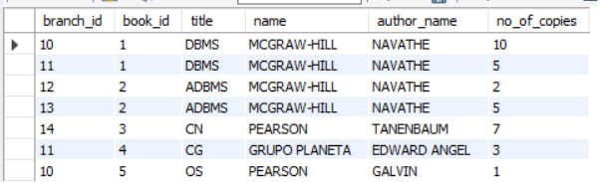

**2.** select card_no from Book_Lending

where date_out between "2017-01-01" and "2017-06-30"

group by card_no

having count(*)>3;

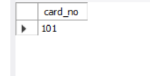

**3.** delete from Book where book_id=1;

Select * from book;

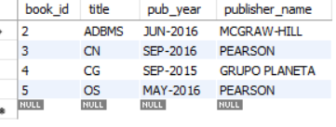

**4.**

create view Year_Publishing as

select pub_year,publisher_name,title from Book;

select * from Year_Publishing;

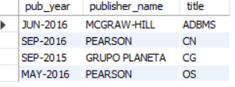

**5.**

create view Book_Copies_Library as

select b.title,bc.no_of_copies,bl.branch_name from Library_Branch bl,Book_Copies bc,Book b

where bl.branch_id=bc.branch_id and

bc.book_id=b.book_id;

select * from Book_Copies_Library;

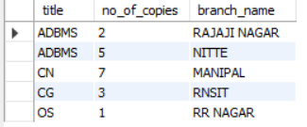

Lab-8

Queries and screenshot:

1. Produce a list of text books (include Course #, Book-ISBN, Booktitle) in the alphabetical order for courses offered by the 'CS' department that use more than two books
2. List any department that has all its adopted books published by a specific publisher.

**1** select b.courseno,b.book_isbn,t.book_title from book_adoption b,text t

where

b.book_isbn=t.book_isbn and

b.courseno in (

select c.courseno from course c,book_adoption b

where

dept="CSE" and

c.courseno=b.courseno

group by b.courseno

having count(*)>2

);

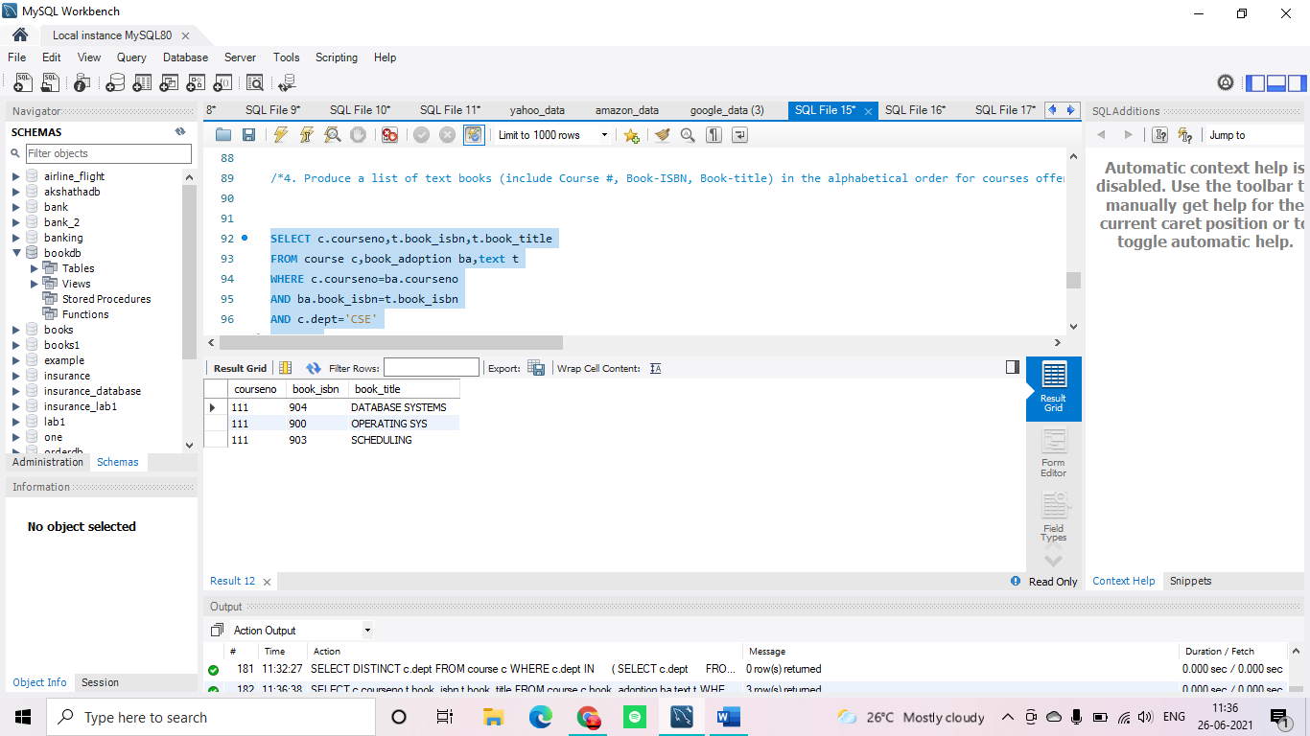

**2**  select c.dept from course c where c.dept in

(

select c1.dept from course c1,text t1,book_adoption b1

where

b1.courseno=c1.courseno and

t1.book_isbn=b1.book_isbn and

t1.publisher='HALL INDIA' and

c1.dept not in (

select c2.dept from course c2,text t2,book_adoption b2

where

b2.courseno=c2.courseno and

t2.book_isbn=b2.book_isbn and

t2.publisher!='HALL INDIA'

)

);

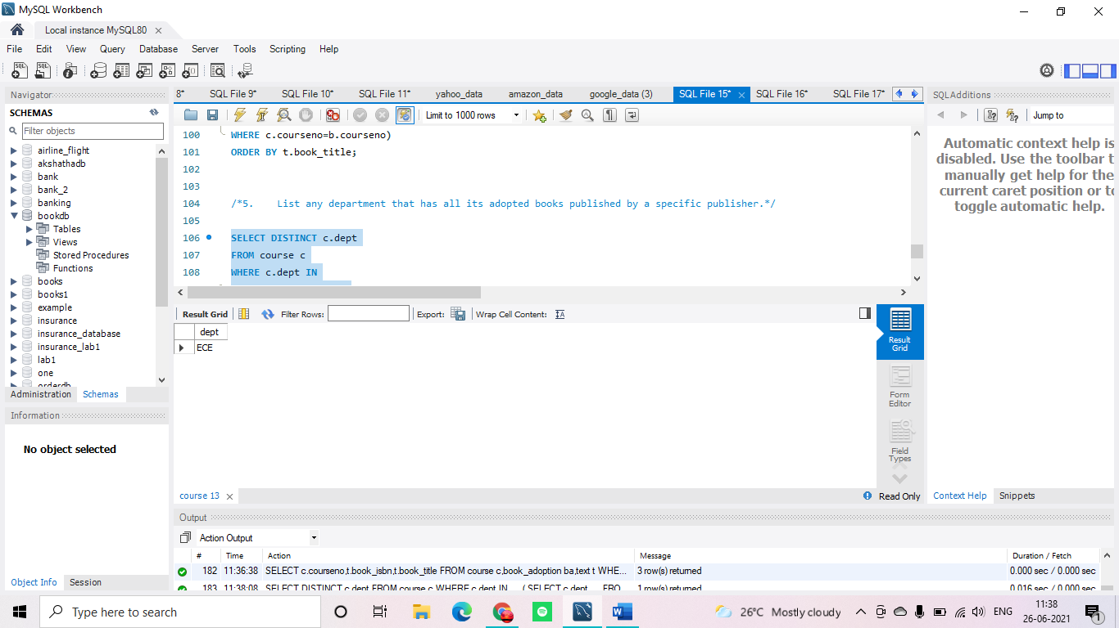

Lab-9

Queries and screenshot:

1. List the titles of all movies directed by ‘Hitchcock’.
2. Find the movie names where one or more actors acted in two or more movies.
3. List all actors who acted in a movie before 2000 and also in a movie after 2015 (use JOIN operation).
4. Find the title of movies and number of stars for each movie that has at least one rating and find the highest number of stars that movie received. Sort the result by movie title.
5. Update rating of all movies directed by ‘Steven Spielberg’ to 5.

**1.** select m.MOV_TITLE from MOVIES m,DIRECTOR d

where

d.DIR_NAME="Hitchcock" and

d.DIR_ID=M.DIR_ID;

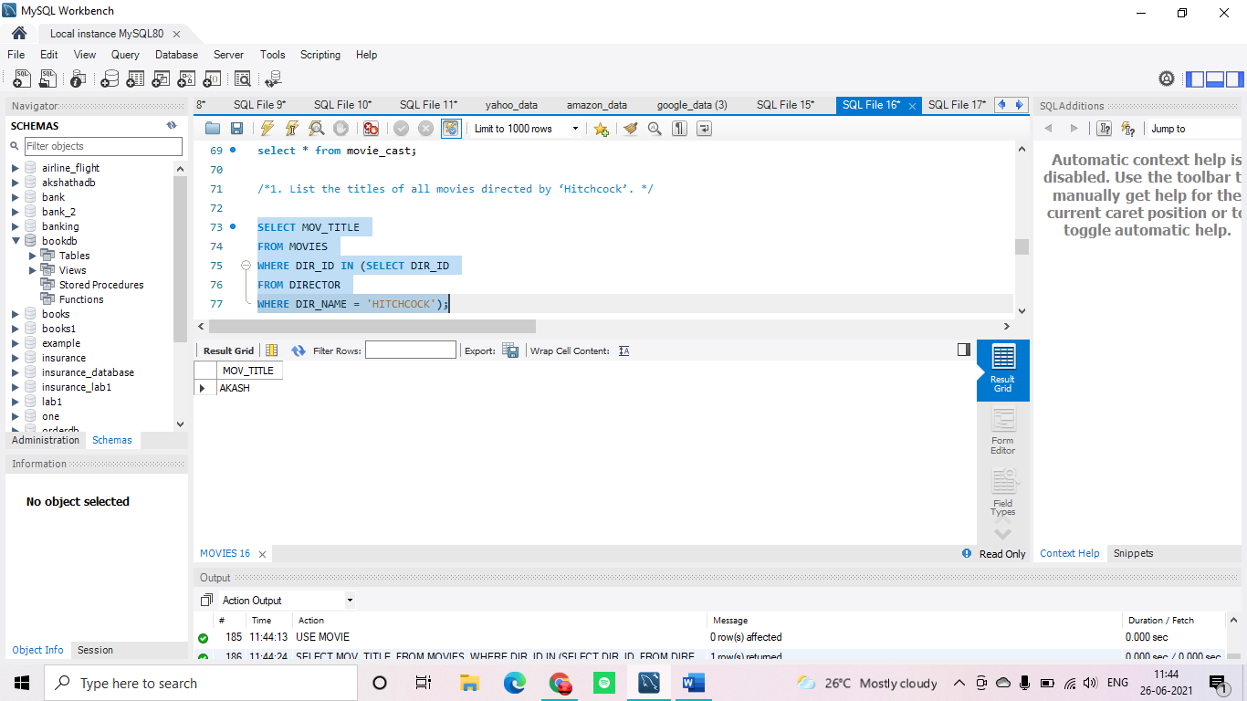

**2.** select m.MOV_TITLE from MOVIES m,MOVIE_CAST mc

where

mc.MOV_ID=m.MOV_ID and

mc.ACT_ID in (

select mc1.ACT_ID from MOVIE_CAST mc1

group by mc1.ACT_ID

having count(*)>=2)

group by m.MOV_TITLE

having count(*)>=1;

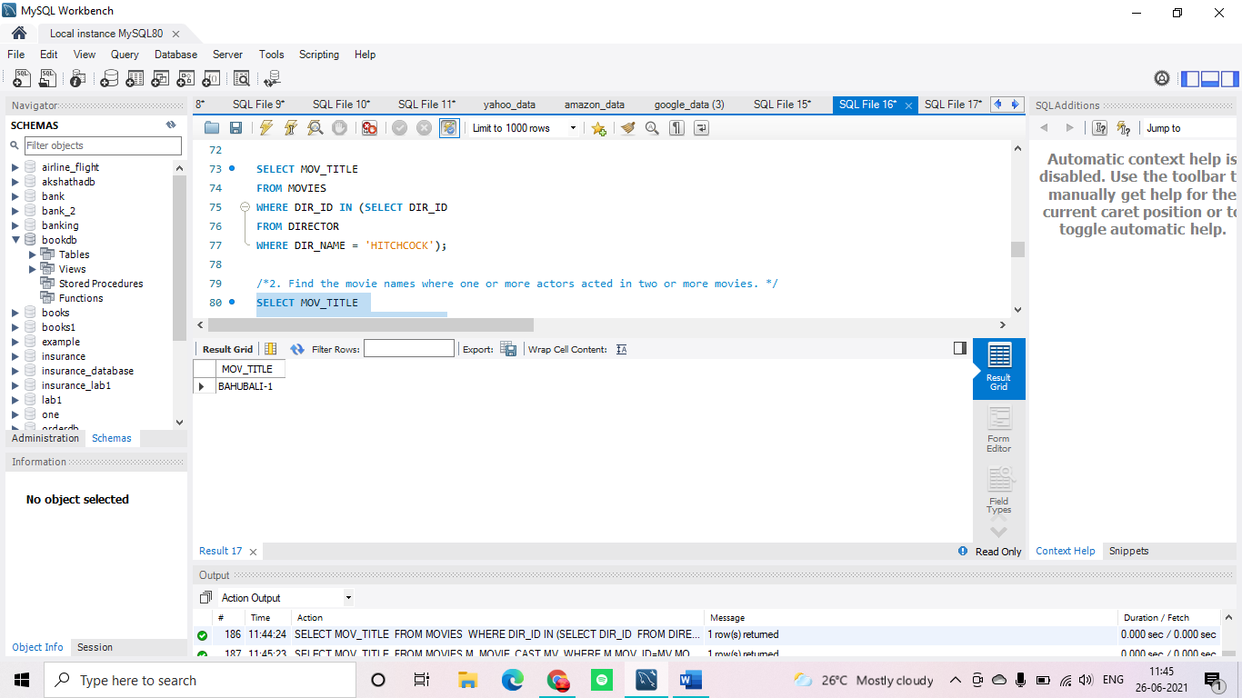

**3.** select a.ACT_NAME,m.MOV_TITLE,m.MOV_YEAR from ACTOR a

join MOVIE_CAST mc

on mc.ACT_ID =a.ACT_ID

join MOVIES m

on m.MOV_ID =mc.MOV_ID

where

m.MOV_YEAR not between 2000 and 2015

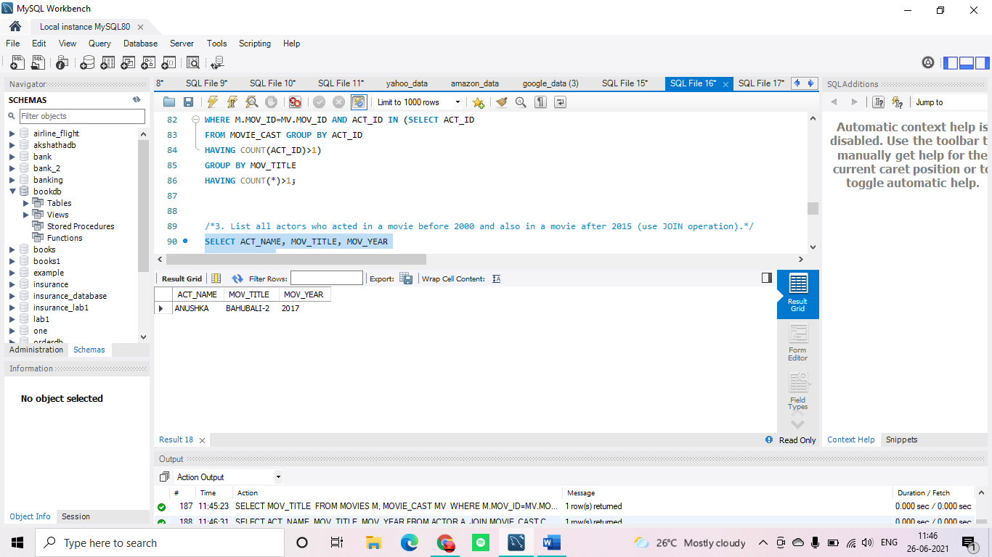

;

**4.** SELECT MOV_TITLE , MAX(REV_STARS) FROM MOVIES M,RATING R

WHERE M.MOV_ID=R.MOV_ID

group by M.MOV_ID

having COUNT(*)>=1

order by MOV_TITLE;

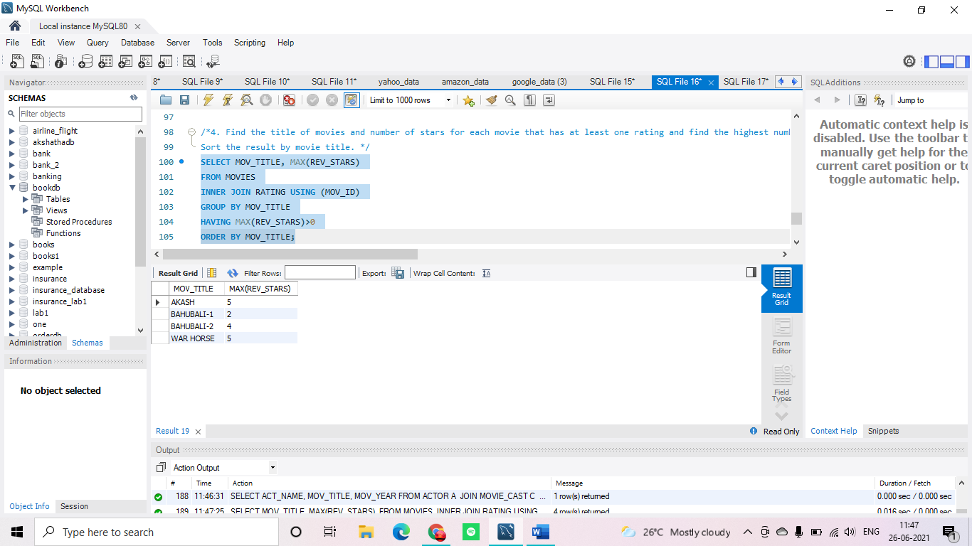

**5.** UPDATE RATING SET REV_STARS=5

WHERE MOV_ID IN (

SELECT MOV_ID FROM MOVIES

WHERE DIR_ID =(

SELECT DIR_ID FROM DIRECTOR

WHERE DIR_NAME="STEVEN SPIELBERG"

)

);

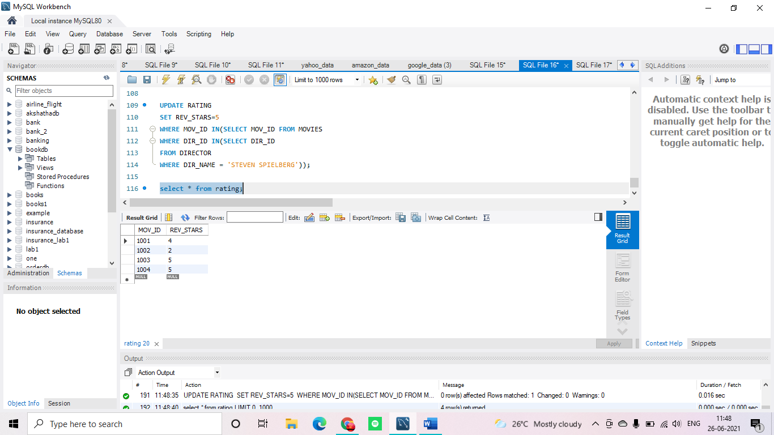

Lab-10

Queries and screenshot:

**1**. List all the student details studying in fourth semester ‘C’ section.

**2**. Compute the total number of male and female students in each semester and in each section.

**3**. Create a view of Test1 marks of student USN ‘1BI15CS101’ in all subjects.

**4**. Categorize students based on the following criterion:

If FinalIA = 17 to 20 then CAT = ‘Outstanding’ If FinalIA = 12 to 16 then CAT = ‘Average’ If FinalIA< 12 then CAT = ‘Weak’ Give these details only for 8th semester A, B, and C section students.

**1.** SELECT * FROM STUDENT S,SEMSEC M,CLASS C

WHERE

S.USN=C.USN AND

C.SSID=M.SSID AND

M.SEM=4 AND

M.SEC="C"

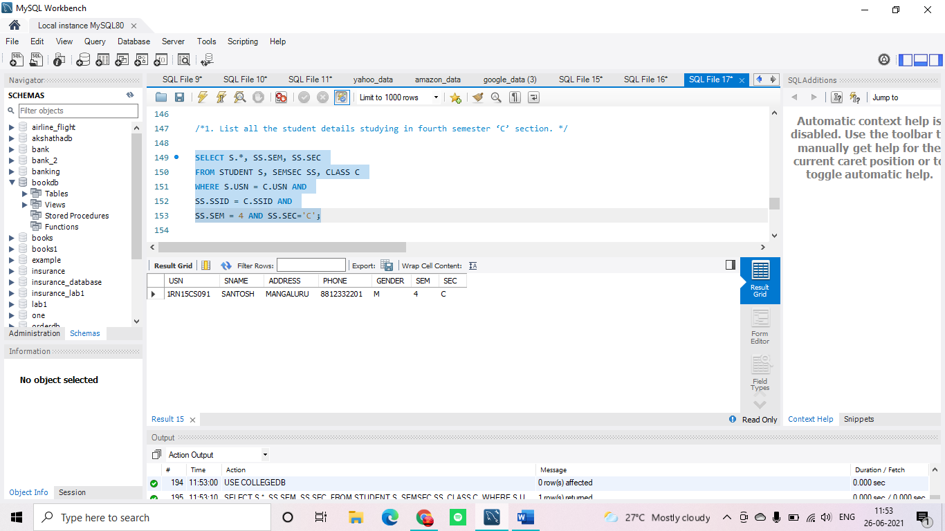

;

**2.** SELECT M.SEC,M.SEM,S.GENDER,COUNT(*) FROM STUDENT S,SEMSEC M,CLASS C

WHERE

S.USN=C.USN AND

C.SSID=M.SSID

group by

S.GENDER,M.SEM,M.SEC

ORDER BY M.SEM;

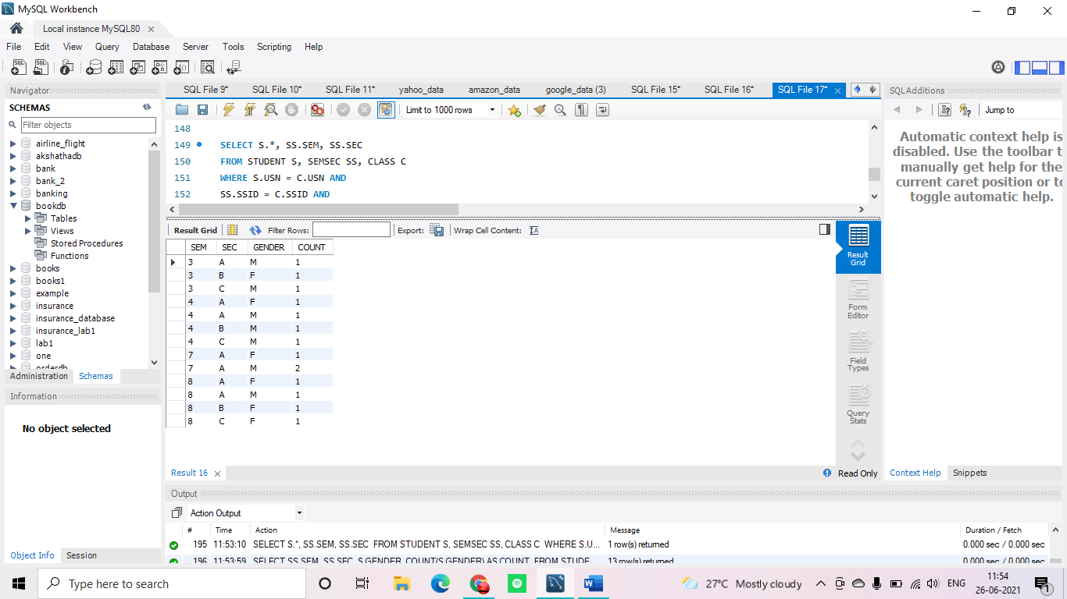

**3.** CREATE VIEW TEST1_1RN13CS091 AS SELECT SUBCODE, TEST1 FROM IAMARKS WHERE USN="1RN13CS091";

SELECT * FROM TEST1_1RN13CS091;

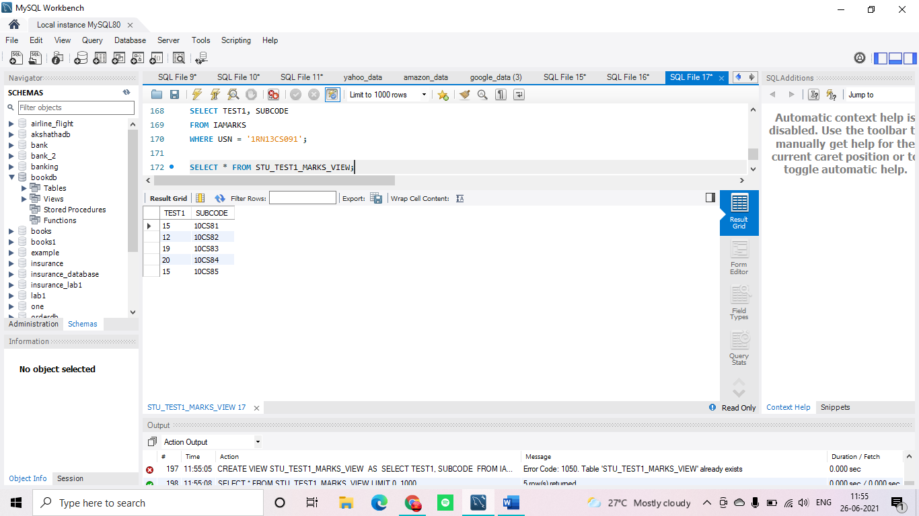

**4.** UPDATE IAMARKS SET FINALIA=(TEST1+TEST2+TEST3)/3;

select * from iamarks;

(SELECT I.USN,SUBCODE,FINALIA,"OUTSTANDING" FROM IAMARKS I,SEMSEC S WHERE S.SSID=I.SSID AND S.SEM=8 AND (S.SEC="A"OR S.SEC="B"OR S.SEC="C") AND FINALIA between 17 AND 20)

UNION

(SELECT I.USN,SUBCODE,FINALIA,"AVERAGE" FROM IAMARKS I,SEMSEC S WHERE S.SSID=I.SSID AND S.SEM=8 AND (S.SEC="A"OR S.SEC="B"OR S.SEC="C") AND FINALIA between 12 AND 17)

UNION

(SELECT I.USN,SUBCODE,FINALIA,"WEAK" FROM IAMARKS I,SEMSEC S WHERE S.SSID=I.SSID AND S.SEM=8 AND (S.SEC="A"OR S.SEC="B"OR S.SEC="C") AND FINALIA <12)

;

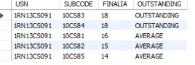

Lab-6

Order database

**Code:**

create database order_dab;

use order_dab;

create table Salesman

(salesman_id int primary key not null,

name varchar(25),

city varchar(25),

commission real);

create table Customer

(customer_id int primary key not null,

cust_name varchar(25),

city varchar(25),

grade int,

salesman_id int,

foreign key(salesman_id) references Salesman(salesman_id)on delete set null);

create table Orders(

order_no int,

purchase_amt real,

ord_date date,

customer_id int,

salesman_id int,

foreign key(customer_id) references Customer(customer_id) on delete cascade,

foreign key(salesman_id) references Salesman(salesman_id) on delete cascade);

insert into salesman values

(1000,"JHON","BANGALORE",25),

(2000,"RAVI","BANGALORE",20),

(3000,"KUMAR","MYSORE",15),

(4000,"SMITH","DELHI",30),

(5000,"HARSHA","HYDRABAD",15);

insert into Customer values

(10,"PREETHI","BANGALORE",100,1000),

(11,"VIVEK","MANGALORE",300,1000),

(12,"BHASKAR","CHENNAI",400,2000),

(13,"CHETHAN","BANGALORE",200,2000),

(14,"MAMATHA","BANGALORE",400,3000);

insert into Orders values

(50,5000,"2017-05-04",10,1000),

(51,450,"2017-01-20",10,2000),

(52,1000,"2017-02-24",13,2000),

(53,3500,"2017-04-13",14,3000),

(54,550,"2017-03-09",12,2000);

select * from salesman;

select *from customer;

select * from orders;

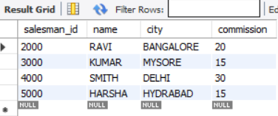

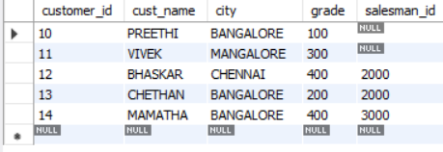

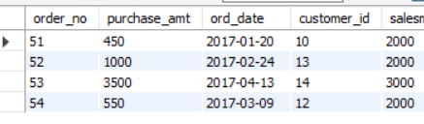

**1.** select count(*) from Customer

where grade>(select avg(grade) from Customer where city="BANGALORE");

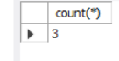

**2.**

select s.salesman_id,s.name from Salesman s,Customer c

where

s.salesman_id=c.salesman_id

group by c.salesman_id

having count(*)>1;



**3**.

SELECT s.salesman_id, name, cust_name, commission

FROM Salesman s, Customer c

WHERE s.city = c.city

UNION

SELECT salesman_id, name, 'NO MATCH', commission

FROM Salesman

WHERE NOT city = ANY

(SELECT city

FROM Customer)

ORDER BY 2 DESC;

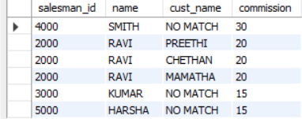

**4.**

create view HighestOrder as

select o.ord_date,s.salesman_id,s.name from Salesman s,Orders o

where s.salesman_id=o.salesman_id and

o.purchase_amt= (select max(purchase_amt) from Orders where ord_date=o.ord_date);

select * from HighestOrder;

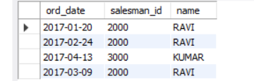

**5.**

delete from Salesman where salesman_id=1000;

select * from Salesman;

select * from Orders;

select * from Customer;

